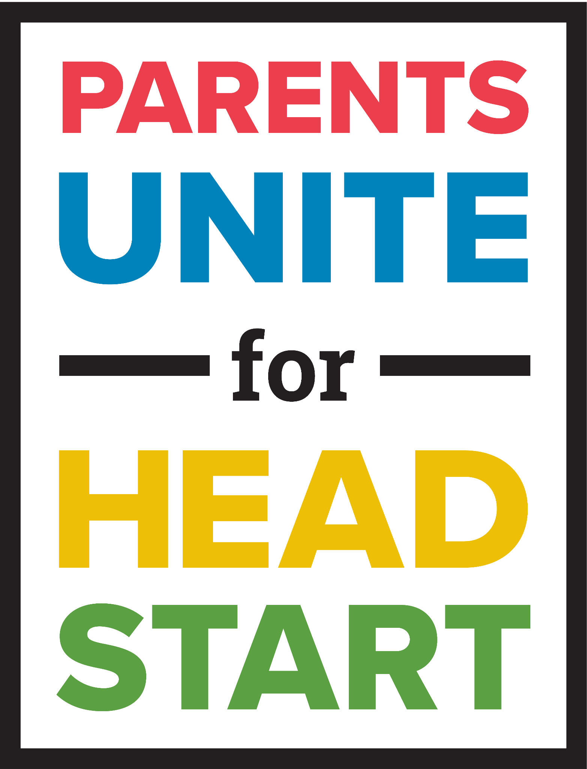
Join Today !

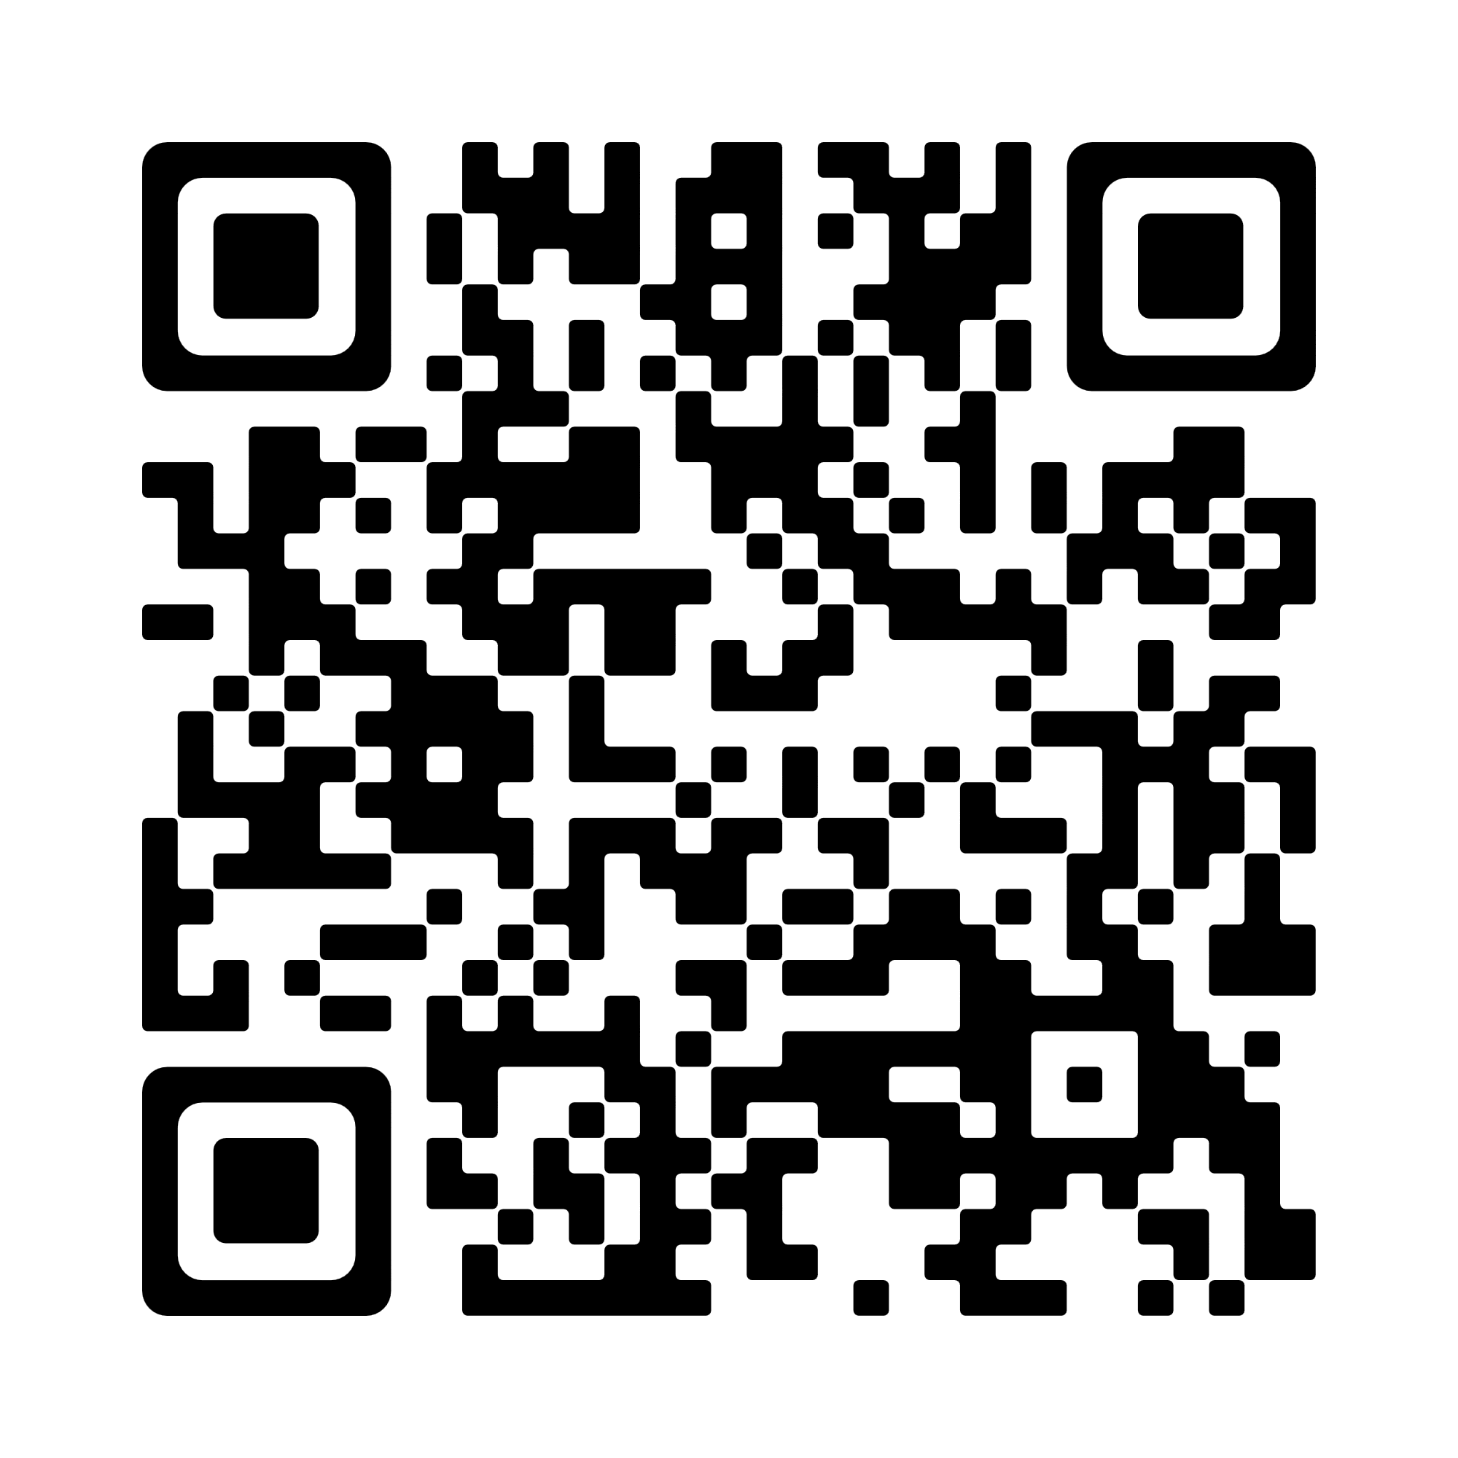

The Parents Unite campaign is a strategic, collaborative effort to increase and elevate Head Start parents taking action and raising their voices. Scan the QR code to sign up and be part of this national movement.

All Head Start parents, caregivers, alumni, staff and supporters are encouraged to join the campaign. The campaign is for everyone.

To learn more go to: www.nhsa.org/parents-unite

